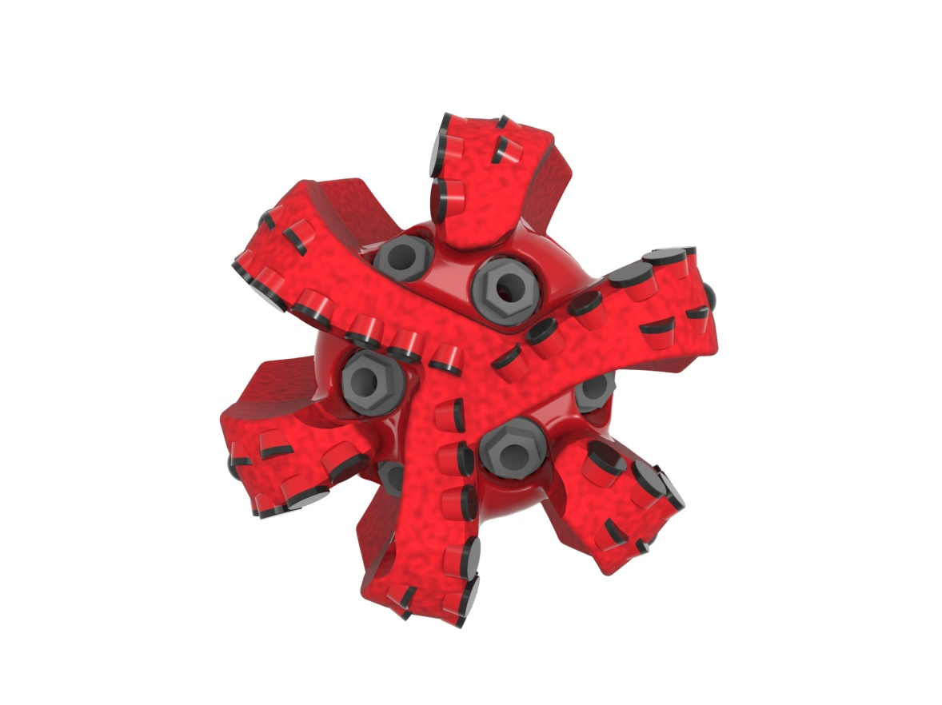
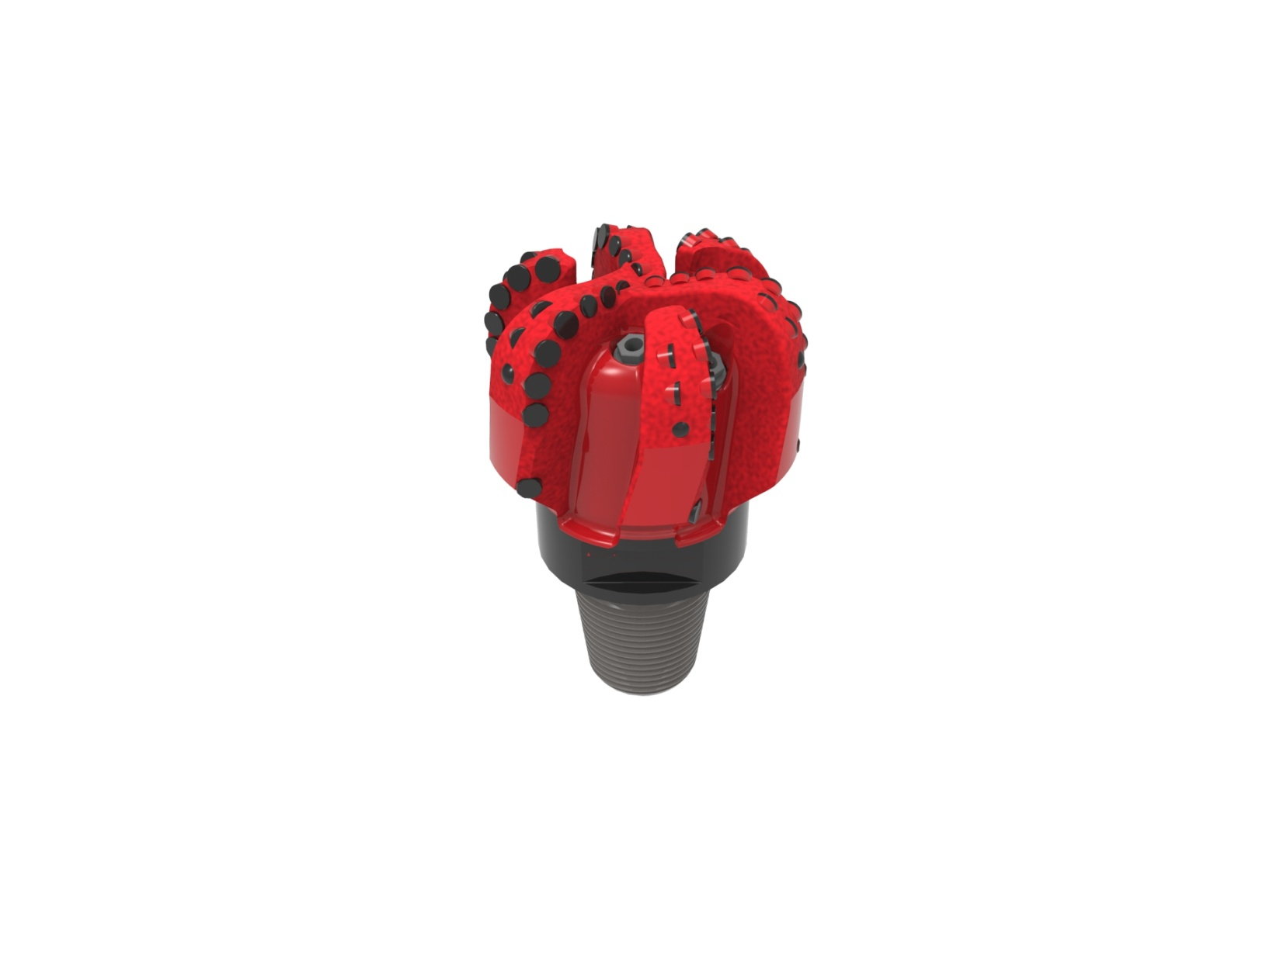

Drill Bit Specifications:
Cutter Size (Primary, Sec) | 1/2”,7/16”
Cutter Count (Total,Gage,Back Ream) | 54,12,6
Blade Count | 6
Gage Length (Inches) | 1.50
Nozzle Count (Primary, Sec.) | 6
Nozzle Series (Primary, Sec.) | 55
JSA (Sq. Inches) | 12.20
Max. TFA (Sq. Inches) | 1.18
Operating Parameters:
Max. Hydraulic Flow Rate (GPM) | 306
Max. Weight on Bit (1,000 Lbs.) | 28
Make-up Torque (ft/lbs) | 8,913
Nominal Dimensions:
Overall Length (Inches) | 10.65
Make Up Length (Inches) | 6.90
Bit Breaker | SKB-21012
Connection | Ø3-1/2" API Reg.
Approx. Weight (Lbs.) | 45

Tailor-Made Features:

- Premium grade cutters maximize ROP and Bit Life

- Nozzle configuration and large open face volume optimize blade cleaning and cuttings removal

613-XR(BR) Nomenclature Explained:

• | 6 | = | Number of Blades
• | 13 | = | Primary Cutter Size (13mm)
• | XR+ | = | Backup Cutters
• | BR | = | Back Reaming Cutters


